**VIKTORY II**

**Terrain and Units Supported (Rules v2.1)**

Naval Support

**Defending**

**Not cumulative;** use only the single best.

**N/A**

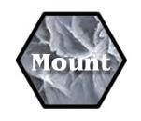

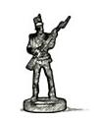

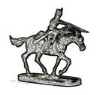

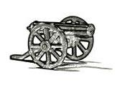

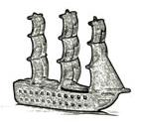

**Type**

**Movement**

**N/A**

Ignores

Slow Terrain

**N/A**

**Attacking**

**N/A**

Pre-Battle Fire

Water / Port only

Transport 3 units

Ship to Ship





Reserve

**VIKTORY II**

**Terrain and Units Supported (Rules v2.1)**

 + =

+ =+

+ 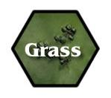=+ 

+ =+ 

+ =+ 

Reserve

Naval Support

**Defending**

**Not cumulative;** use only the single best.

**N/A**











**Type**

**Movement**

**N/A**

Ignores

Slow Terrain

**N/A**

**Attacking**

**N/A**

Pre-Battle Fire

Water / Port only

Transport 3 units

Ship to Ship





 + =

+ =+

+ =+ 

+ =+ 

+ =+ 